KIT (W557R)
Catalog Number: CR-M26275
Gene Symbol: C-Kit; CD117; KIT; PBT; SCFR
Description: Anti-KIT (W557R) Mouse Monoclonal Antibody

Background: Tyrosine-protein kinase Kit, also known as proto-oncogene c-Kit or CD117 or Mast/stem cell growth factor receptor (SCFR), is a receptor tyrosine kinase protein that in humans is encoded by the KIT gene. Activating mutations in this gene are associated with gastrointestinal stromal tumors, testicular seminoma, mast cell disease, melanoma, acute myeloid leukemia, while inactivating mutations are associated with the genetic defect piebaldism.
Immunogen: A synthetic peptide from the internal region of KIT which includes the mutation of W557R, human origin.
Tested applications: ELISA, WB
Recommended dilutions:
ELISA: 1:1000-1:5000
WB: 1:500-1:1000
Concentration: 1 mg/ml
Host: Mouse
Clonality: Monoclonal
Purity: Purified from ascites
Format: Liquid
Storage buffer:
Preservative: no
Constituents: PBS (without Mg²⁺ and Ca²⁺), pH 7.4, 150 mM NaCl, 50% glycerol
Species Reactivity: Recognizes W557R mutant, but not wild-type KIT of vertebrates.
Storage Conditions: Store at -20°C. Avoid
freeze / thaw cycles.

Western blot:
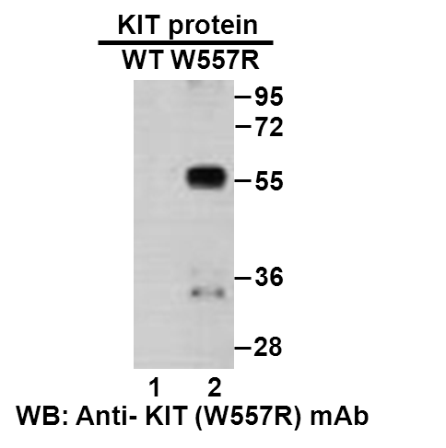
Western blot analysis of recombinant KIT (W557R) and wildtype proteins. Purified His-tagged KIT (W557R) protein (lane 2) and corresponding wildtype protein (lane 1) were blotted with anti-KIT (W557R) monoclonal antibody (Cat. #26275).

科博瑞（武汉）生物科技有限公司
TEL：027-87615885 15972062685
- mail：3636901710@qq.com
Web:www.coburybio.com

